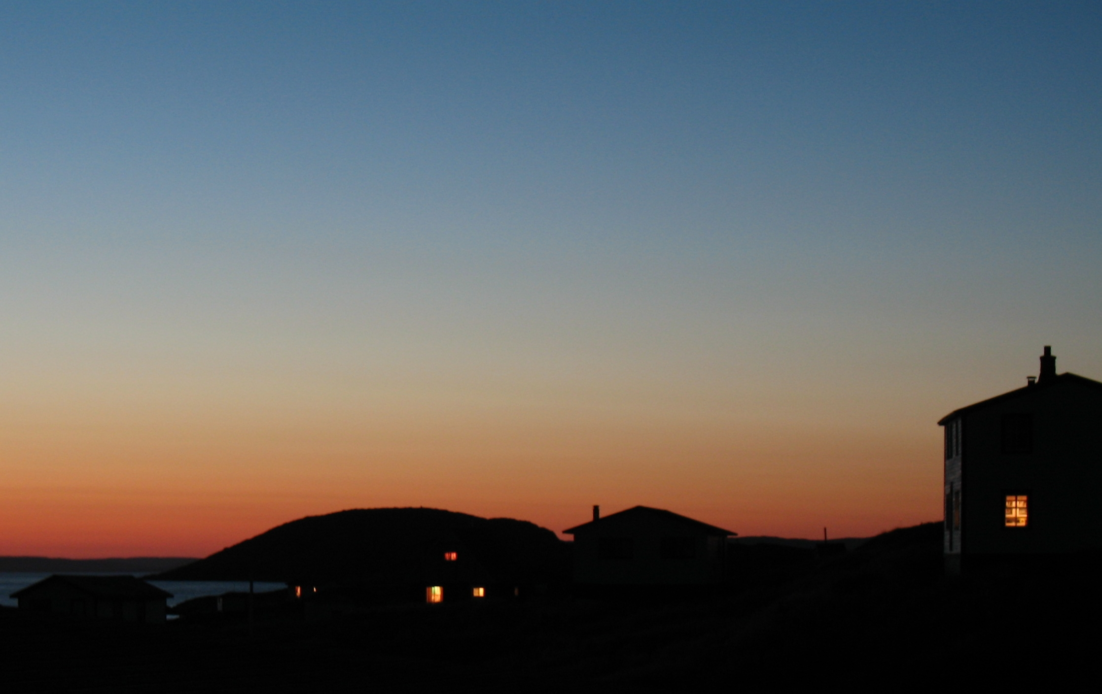
Labrador Tourism Industry Stakeholder Update and Consultation Workshop

L’Anse au Clair, September 13-14, 2010

Report Prepared by:

Randy Letto, Executive Director
Destination Labrador
September, 2010

Table of Contents

A G E N D A 4

Executive Summary 5

1. 0 Opening Remarks 7

2.0 Industry Updates 7
2.1 Q/A Session 9

3.0 Review of Stakeholder Consultations 10

4.0 Sponsored Presentations 11

5.0 Travel Generators/Influencers: 11
5.1 Cultural 11
5.2 Natural 11
5.3 Outdoor 12
5.4 Market Readiness/Quality Assurance 12
5.5 Sustainability of Anchor Attractions 13
5.6 Multi-Season Destination 13

6.0 Medium Long-term Priorities 14

7.0 List of Participants 15



2010 TOURISM INDUSTRY STAKEHOLDER
UPDATE & CONSULTATION WORKSHOP
September 13th & 14th, 2010
Conference Room, Northern Light Inn, L’Anse au Clair

A G E N D A
Monday, September 13, 2010 (3:00 p.m. to 6:00 p.m.)

3:00 p.m. Industry Update (20 Min.)
3:20 p.m. Destination Labrador Update (20 Min.)
3:40 p.m. Review of Stakeholder Consultations (15 Min.)
3:55 p.m. New Tourism Board Progress (30 Min.)
4:25 p.m. Nutrition Break (15 Min.)
4:40 p.m. Travel Generators / Influencers: (1.5 Hrs.)
a) Cultural
b) Natural
c) Outdoor Activity
~
~ END OF DAY ONE SESSION ~
~
TUESDAY, SEPTEMBER 14, 2010 (8:00 a.m. to 12:00 p.m.)

8:00 a.m. Continental Breakfast (30 Min.)
8:30 a.m. Recap of Previous Day (15 Min.)
8:45 a.m. Market Readiness / Quality Assurance (30 Min.)
9:15 a.m. Sustainability of Anchor Attractions (30 Min.)
9:45 a.m. Nutrition Break (15 Min.)
10:00 a.m. Multi-Season Destination: (30 Min.)
a) Season extension May / June
b) Season extension September / October
c) Winter Products / Events
10:30 a.m. Packaging (30 Min.)
11:00 a.m. Medium and Long Term Priorities (30 Min.)
11:30 p.m. Other (30 Min.)

Executive Summary

Labrador’s uncommon potential in the tourism industry is a top of mind priority for many municipalities, community-based organizations and even more so for the many family-run enterprises with a vested interest in its continued growth and expansion.

“The Newfoundland and Labrador Tourism Vision 2020 (Vision 2020) provides a blueprint for extraordinary growth. It addresses the real and perceptual barriers facing our industry with innovative strategies and actions. And it challenges us to come together as entrepreneurs, industry partners, and Government to grow our industry to new heights: to double the annual tourism revenue in Newfoundland and Labrador by 2020.”

As a Tourism Board representative for the Labrador region, Destination Labrador is responsible to both Labrador tourism stakeholders and the Board in identifying the Labrador industry priorities for marketing support, product development and market readiness and quality assurance.

Over the past 12 months, Destination Labrador and its partner stakeholder groups have organized a series of industry consultation sessions in each of the four regions of Labrador. A particular focus of these consultation sessions was to identify “Labrador’s” role in doubling the annual tourism revenue for the province. Most recently, Destination Labrador held a pan-Labrador session in L’Anse au Clair (September 13th & 14th, 2010) to recap existing input from these consultation and seek final input on Labrador’s tourism development priorities for 2011.

This report is a summary of those short-term priorities related to product development, market readiness and quality assurance.

The following priorities and highlights include new ideas and proposed projects. In some cases further cost-benefit analysis, business planning or detailed project costing is required. Follow up to be completed by Destination Labrador and project proponents.

- Transportation and Communications:
  - Service review of the transport network and ferry services (Blanc Sablon - St. Barbe service, Battle Harbour service, Northern Ranger, Trans Labrador Highway)
  - Signs for Trans Labrador Highway
  - Phase II/III Trans Labrador Highway roadside pull-offs and enhancements.
  - Public washrooms on Trans Labrador Highway or Phase II and Phase III
  - VIC Gateway services (Labrador West, Happy Valley-Goose Bay, Port Hope Simpson)*
  - Wi-Fi Hot Spots – Phase II/III, Battle Harbour, Red Bay
  - Broadband service*
  - Port facilities Red Bay/Cartwright*

- Product Development:
  - Nature Based
    - Hiking trail improvements (pioneer footpath in Labrador Straits, old angler trails at Pinware River, Bowdoin Canyon, Muskrat Falls)
    - IT Application for self-guided nature touring
    - GPS database of trails
    - Geo-Caching program development
  - Culture Based
    - Experiential product development (mentorship program with professional interpreters (supported by Parks Canada//Harris Center/CONA/QLF/GeoCenter Outreach) and community HR/entrepreneurs
    - Community workshops and HR capacity development
  - Outdoor Based
    - New groomed trails, trail realignment and maintenance
    - Labrador Winter Trails workshop and business plan
    - Cain’s Quest marketing/planning/event management
    - Trapline Marathon/Great Labrador Canoe Race
    - Provincial park (Paradise River)*
    - Availability of professional guide services*

- Market Readiness and Quality Assurance:
  - Cuisine*
  - Assessment and Business Planning – Battle Harbour, Labrador Coastal Drive pilot
  - Tourism Technology pilot – Labrador Coastal Drive
  - Quality Assurance Program/Coordination

- Sustainability of Anchor Attractions:
  - Battle Harbour
  - Torngat Mountains National Park Base Camp
  - Road access to Point Amour, Port Hope Simpson*
  - Professional staff/training

- Multi-Season Destination:
  - Research required to determine best strategy/consumer focus
  - Enhancement of existing festival and events
  - Workshop and business planning for small conferences/events/festivals with non-resident appeal*

* indicates medium to long-term planning horizons

1.0 Opening Remarks

Chad Letto, Chairperson for Destination Labrador opened the session by thanking those in attendance for taking time away form their business and work to participate in this industry stakeholder session and asked Randy Letto, Executive Director for Destination Labrador, to explain the session purpose and agenda.

Randy Letto outlined the following:

- The session Agenda (see attached)
- The purpose and intent of the session to focus on product development
- Relevance to the new Tourism Board and it’s investment planning
- Importance of focusing discussion on the short-term planning (12-18 months)
- This was a continuation of stakeholder consultations that started in the Fall of 2009

2.0 Industry Updates

D. Pike (Oceanview Resort):
- Having a busy season
- Message is now out about the region that there is a new road
- Having HR challenges
- Looking at immigration to fill vacant positions
- Overall it was a good year

M. Bridle: (Whalers Station Restaurant, Cabins and Craft Store)
- June was a good, August was down
- Traffic passing through Red Bay not stopping
- Their new product was offered certain days per week only, maybe multiple times/week will work better in 2011

C. Letto: (Northern Light Inn)
- Exciting and speechless year
- Yet challenging operations wise
- Increased commercial business
- The Sir Robert Bond schedule in winter had a very positive impact
- Best year in history of business
- Staffing an issue
- Need new product for evening which requires staff and training
- Now started building 14 new rooms to the property
- need HR for new ideas

S. Letto: (Labrador Coastal Drive Tourism Association)
- The Labrador Coastal Drive Tourism Association is an organization of industry partners addressing common issues
- Partners are challenged with increased business operations resulting in less time for their Association
- Current work includes are the vision 2020 priorities, spring advertising, reprint travel guide, ad blitz on CFCB radio, not sure about advertisement affects on traffic
- There are 15 members from industry
- There is a voluntary collection of a tourism incentive fee (2%) of the room rates that, funds there marketing/advertisement

P. Barrett: (Experience Labrador)
- Very different year for them, but a good year
- August was slow
- Sales was up overall
- No sign on highway for south bound traffic from Happy Valley-Goose Bay
- Craft demonstrations lured new customers to shop
- Noticeable Europeans traffic in July
- August better month for tours
- Gallery sales down in August
- They extended season in September by one week, next year will see some changes

P. Rumbolt: (Noel Lodgings)
- August was really busy
- Best year ever
- Need more workers
- Looking at expanding with a craft shop and an RV park

D. Robbins: (Labrador Straits Historical Development Corporation, operators of the Point Amour Provincial Historical Society and Gateway Visitor Center)
- No crisis like previous years (e.g. ferry) so a good year
- Issues are similar to private like HR
- Communications is a challenge to visitors because the need is immediate,
- Transportation is always a concern
- A struggle to get staff with a pattern that shows it is getting worse each year, mature college students not returning
- Gateway/Point Amour lighthouse is main operations, visitation dropped off in September
- Interest in travelling beyond Red Bay which requires information and updated road conditions. Working on new product > pioneer footpath

T. Taylor-Walsh: (Parks Canada)
- Visitation up 15% at Red Bay National Historical Site
- All National Historical Sites up
- No new activity offer
- Product planning focus will turn to Red Bay in the new year
- Communications key

2.1 Question/Answer Session

S. Downer: If an increase, what is the nature of it? Is it resident or non-resident?

P. Barrett: Quebec visitors amazing, a lot of Goose Bay residents visiting Cartwright.

C. Letto: Commercial “yes”, but a new dynamic change in dual sport motorcycles. New clients for his property. Averaging 2/night this summer

T. Taylor-Walsh: The Oceanview Motel in Gros Morne doing washing kits for motorcycle clients, there is an increase in FIT coming from Corner Brook heading to Labrador City. Average pax/bus was up; total departures remain same, but more pax per bus.

D. Pike: Not sure if increased was tourists or residents, the August 12th, 2010 increased in Apollo ferry runs is now ended, motorcyclist were way up, blogs and social media are the key here.

3.0 Review of Stakeholder Consultations

Randy presented a list of product development priorities already documented in previous sessions and asked for input on any gaps. Feedback form the group included a need to ensure the ‘Destination Highway’ concept was included. This was listed under Trans Labrador Highway enhancements.

Draft List in Summary (updated June 24, 2010)

4.0 Sponsored Presentations

Presentations on immigration programs and HR programs and services followed from HRLE staff Erika Stockley and Andy Turnbull.

Randy gave an overview of the role of the Tourism Board and a short presentation on the Uncommon Potential Vision.

5.0 Travel Generators/Influencers

These attractions represent some of the key motivators for travel to Labrador and include places like Battle Harbour, Labrador Interpretation Centre, and Point Amour Lighthouse etc. There are three main areas to cover and a facilitated session follow on each of three main areas: Cultural, Natural and Outdoor.

5.1 CULTURAL
- Traditional skill/craft demonstrations were successful in previous years, however individuals in senior years limit continuation. Check “See How It’s made Campaign,” DITRD
- Existing interpretive officers (like Parks Canada) working with seniors in the community (i.e.: storytelling, etc.) may offer some promise
- Traditional music is needed
- Need to work with Parks Canada interpreters and the various community human resources in the form of pilot programs that match the need of tour operators.
- A lot of work required to take existing ideas to be programmed/schedule offers with a price and some value for the consumer
- Suggested approaches was the Tourism Brokership Model (K. Sheppard, Nunatsiavut Government)
- Suggested approaches the Traditional Skills Network (Craft) (S. Etheridge, Quebec Labrador Foundation)
- The challenge will be in recruitment, so need mentoring from Parks Canada or professional Interpreters

5.2 NATURAL
- Ideas generated in this area include a need for product related to berry picking, astronomy tours for ‘Northern Lights’, Aboriginal perspective storylines in our natural environment and wildflower hikes
- Approaches include a look at models related to applied research and to check with the Harris Center and Grenfell Campus MUN, Newfoundland and Labrador GeoCenter’s outreach program
- Another approach could involve developing an IT application for self-guided nature touring (SMART Labrador)
- Idea: CONA experts over a 3-week period deliver academic knowledge about natural resources to lead development of product around existing self-guided touring publications

5.3 OUTDOOR
- Ideas generated included Geocaching that highlights activity around the Trans Labrador Highway. Focus on the Wilson River Valley, Bowdoin Canyon
- New product to consider for dual sport motorcycles like tour descriptions of Seal Lake/ dykes and service kits at tourism establishments to enhance consumer experiences
- industry needs to be attentive to dual sport motorcyclists and take advantage of this emerging outdoor market segment
- snowmobiling is a big opportunity and the Bond (ferry) is an important access link that previously limited growth
- There is a need for snowmobile trails that are groomed and for ungroomed trail product
- A fall 2010 Labrador Winter Trails Workshop is the next step
- Trail safety is an issue for some Straits area salmon rivers like Pinware where trail growth and poor trail conditions increase risk and danger for anglers
- There is a lack of availability of guides for recreational fishing product
- Local map available showing these old river trails needs to be professional
- Angling licenses are an issue for vendors, it is a cash flow concern when vendors have to prepay for season inventory and reconcile unsold licenses later in the year in some cases the following calendar year
- There should be a day license for Non-Residents and information on where these consumer can fish along the Trans Labrador Highway

5.4 MARKET READINESS/QUALITY ASSURANCE
- Website maintenance requires a local company to provide service external to business/supplier operations
- There is continued demand for broadband, Wi-Fi, and cell coverage in rural towns
- Labrador businesses cannot purchased wireless POS systems if your provider is BELL
- A possible application of Wi-Fi hotspots along the Trans Labrador Highway needs a service provider and some form of partnership; this needs cost-benefit analysis, site survey, business plan

5.5 SUSTAINABILITY OF ANCHOR ATTRACTIONS
- There is a third party MOU to manage operations at Point Amour
- This is a community based approach that works for sites like Point Amour
- Need more investment to meet new consumer needs and desire for enhanced experiences
- Barriers to double revenue - road access needs upgrading/paving, ferry is a bottleneck, road is key, staffing, additional experiences provides value, new product development requires, research, staff/interpreter training,
- Market cross over that reprograms culture sites to look at e.g. nature pursuits e.g. icebergs/whales requires marketing and demand
- At one Labrador operation, management is moving to third-party provider e.g. from Parks Canada to Labrador Inuit Development Corporation in the Torngats,
- Important that in these attractions, there must be a connection to community, local industry plans to ensure sustainability and successful partnerships
- Education and awareness of value of Tourism in community economies
- Battle Harbour is a key attraction, very complex (the site operates as a hotel, a restaurant, a museum, a ferry service, an interpretive center). This site is unique to the province, no third-party community-based management structure (most important difference then all others in Labrador), the ferry fee is a barrier to increasing traffic and packaging may be a solution to sales/visitation

5.6 MULTI-SEASON DESTINATION
- Winter snowmobiling: Need to move beyond just groomed trail focus and accept that certain areas will not be groomed,
- Events like Cain’s Quest is bringing new tour operators,
- Maybe new Labrador wide leisure event,
- Other events for cross country skiing in Labrador West is inhibited by accommodation availability,
- Shoulder season (is it May/June or September/October), spring requires research to determine who the consumers are.
- Small conferences in fall may offer near immediate results
- Enhancement of existing and new events (Trapline Marathon, Cain’s Quest, Great Labrador Canoe Race, Bakeapple festival, etc maybe the best approach to extending season.
- There is a need for a further workshop to review these options in detail. The outcome being a comprehensive calendar of events with some focused planning to appeal to non-residents

6.0 Medium Long-term Priorities

The following is a cursory review of top of mind priorities that requires a further consultation session in order to prioritize and finalize. (“x” means others who are in agreement)

- Collaboration and communications – along the Trans Labrador Highway x5
- Transportation (including ferries) i.e. Route 138, 500 x3
- Engagement with Destination Labrador/DMO x2
- Packaging – offers but not sold, x2
- Experiential product, HR x2
- Visitor Services – Signage, VICs
- Marketing – needs more private and public industry investment
- Labrador Coastal Drive Tourism Association needs support
- Quality – product, packaging, service that meets the marketing promises, the Labrador experience
- Food Quality and local produce
- Broadband

7.0 List of Participants

ORGANIZATION | REPRESENTATIVE
ACOA | Trevor Kennedy
Department of Tourism, Culture & | Rhonda Hutton
Recreation | Juanita Keel-Ryan
 | Todd Kent
Smart Labrador | Sheila Downer
HRLE (Human Resources) | Erika Stockley
 | Andy Turnbull
Nunatsiavut Government | Kristy Sheppard
Regional Development Boards:
Southeast Aurora Dev. | Margaret Rumbolt
Hyron | Linda Dumaresque
Regional Tourism Associations:
Labrador Coastal Drive | Shirley Letto
Combined Councils of Labrador | Janice O’Neill
Parks Canada | Trudy Taylor-Walsh
Oceanview Resort | Delbert Pike
Whaling Station Cabins/Restaurant | Marilyn Kippenhuck-Bridle
Lab. Straits Historical Dev. Corp. | Phillip Bridle / Doug Robbins
Experience Labrador | Pete Barrett
L’Anse au Clair – Town Clerk | Loretta Griffen
L’Anse au Loup – Town Manager | Lawrence Normore
Quebec Labrador Foundation | Serena Etheridge
Noel Lodging & Hospitality Suites | Paulette Rumbolt
Destination Labrador | Randy Letto
 | Keith Small
 | Leo Abbass
 | Chad Letto

